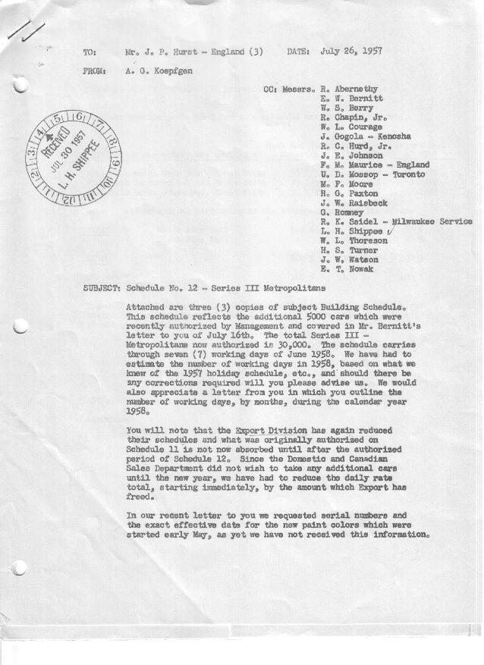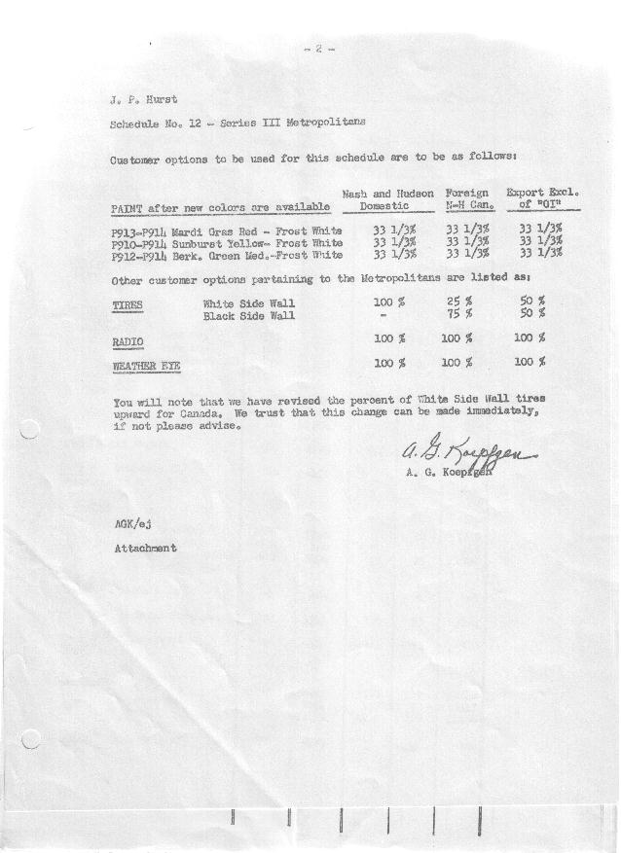

FORM PLAN 68 REV. 2-55-A.M.P Page 1 of 2 APPROVED R. Abernethy (signed) DATE 7/29/57

SCHEDULE NO. ______12 ___ DATE 7/24/57 MONTHLY BUILDING SCHEDULE APPROVED R.W. Chapin Jr. (signed) ___ _ DATE_ 7/29/57 _
REVISION NO. _______ ______ DATE PRODUCT APPROVED E.W. Bernitt (signed)) DATE _ 7/30/57 ____
SERIES III 1500 c.c. ENGINE
METROPOLITAN SERIES CARS – AUSTIN MOTORS CO., LTD, ENGLAND
DESCRIPTION | BUILT  ◻ACTEST  THRU  6/30/57 | FIRM BUILDING SCHEDULE  (FABRICATED MATERIAL RELEASE) |  |  |  |  |  |  |  |  |  |  |  |  |  |  | TENTATIVE SCHEDULE  (RAW MATERIAL RELEASED) |  |  | GRAND  TOTAL
DESCRIPTION | BUILT  ◻ACTEST  THRU  6/30/57 | MONTH July “57”  DAYS 20 |  |  | MONTH August  DAYS 15 |  |  | MONTH September  DAYS 21 |  |  | MONTH October  DAYS 23 |  |  | MONTH November  DAYS 21 |  |  | MONTH December  DAYS 19 |  |  | GRAND  TOTAL
DESCRIPTION | BUILT  ◻ACTEST  THRU  6/30/57 | DAILY | MONTH | CUM’L  TOTAL | DAILY | MONTH | CUM’L  TOTAL | DAILY | MONTH | CUM’L  TOTAL | DAILY | MONTH | CUM’L  TOTAL | DAILY | MONTH | CUM’L  TOTAL | DAILY | MONTH | CUM’L TOTAL | GRAND  TOTAL
DOMESTIC LHD:
Hard-Top | 13474 |  | 653 | 14127 |  | 660 | 14787 |  | 924 | 15711 |  | 1012 | 16723 |  | 924 | 17647 |  | 681 | 18328
Soft-Top | 1962 |  | 261 | 2223 |  | 90 | 2313 |  | 126 | 2439 |  | 138 | 2577 |  | 126 | 2703 |  | 75 | 2778
Total U.S. | 15436 | 45.7 | 914 | 16350 | 50.0 | 750 | 17100 | 50.0 | 1050 | 18150 | 50.0 | 1150 | 19300 | 50.0 | 1050 | 20350 | 39.8 | 756 | 21106
Over/(Under) Schedule 11 | 86 |  | (86) | -0- |  | -0- | -0- |  | -0- | -0- |  | -0- | -0- |  | -0- | -0- |  | -0- | -0-
FOREIGN:
EXPORT LHD Hard-Top | 531 |  | 30 | 561 |  | 22 | 583 |  | 30 | 613 |  | 36 | 649 |  | 26 | 675 |  | 13 | 688
Soft-Top | 248 |  | 14 | 262 |  | 14 | 276 |  | 14 | 290 |  | 12 | 302 |  | 14 | 316 |  | 7 | 323
Total Export LHD | 779 |  | 44 | 823 |  | 36 | 859 |  | 44 | 903 |  | 48 | 951 |  | 40 | 991 |  | 20 | 1011
RHD Hard Top | 19 |  | 30 | 49 |  | 15 | 64 |  | 30 | 94 |  | 25 | 119 |  | 30 | 149 |  | 15 | 164
Soft Top | 12 |  | 10 | 22 |  | 10 | 32 |  | 10 | 42 |  | 3 | 45 |  | 10 | 55 |  | 3 | 58
Total Export RHD | 31 |  | 40 | 71 |  | 25 | 96 |  | 40 | 136 |  | 28 | 164 |  | 40 | 204 |  | 18 | 222
Grand Total Export | 810 | 4.2 | 84 | 894 | 4.1 | 61 | 955 | 4.0 | 84 | 1039 | 3.3 | 76 | 1115 | 3.8 | 80 | 1195 | 2.0 | 38 | 1233
Over/(Under) Schedule 11 | (184) |  | (37) | (221) |  | (59) | (280) |  | (35) | (315) |  | (58) | (373) |  | (53) | (426) |  | (109) | (535)
CANADA Hard-Top | 1665 |  | 68 | 1733 |  | 45 | 1778 |  | 64 | 1842 |  | 86 | 1928 |  | 30 | 1958 |  | 10 | 1968
Soft-Top | 148 |  | 0 | 148 |  | 0 | 148 |  | 0 | 148 |  | 0 | 148 |  | 0 | 148 |  | 5 | 153
Total Nash Canada | 1813 | 3.4 | 68 | 1881 | 3.0 | 45 | 1926 | 3.0 | 64 | 1990 | 3.7 | 86 | 2076 | 1.4 | 30 | 2106 | .8 | 15 | 2121
Over/(Under) Schedule 11 | (8) |  | 8 | -0- |  | (15) | (15) |  | (11) | (26) |  | 26 | -0- |  | -0- | -0- |  | (5) | (5)
TOTAL FOREIGN | 2623 | 7.6 | 152 | 2775 | 7.1 | 106 | 2881 | 7.0 | 148 | 3029 | 7.0 | 162 | 3191 | 5.2 | 110 | 3301 | 2.8 | 53 | 3354
Over/(Under) Schedule 11 | (192) |  | (29) | (221) |  | (74) | (295) |  | (46) | (341) |  | (52) | (393) |  | (53) | (426) |  | (114) | (540)
GRAND TOTALS
Hard-Top | 15689 | 39.1 | 781 | 16470 | 49.4 | 742 | 17212 | 49.9 | 1048 | 18260 | 50.4 | 1159 | 19419 | 48.1 | 1010 | 20429 | 37.8 | 719 | 21148
Soft-Top | 2370 | 14.2 | 285 | 2655 | 7.6 | 114 | 2769 | 7.1 | 150 | 2919 | 6.6 | 153 | 3072 | 7.1 | 150 | 3222 | 4.7 | 90 | 3312
Total | 18059 | 53.3 | 1066 | 19125 | 57.0 | 856 | 19981 | 57.0 | 1198 | 21179 | 57.0 | 1312 | 22491 | 55.2 | 1160 | 23651 | 42.5 | 809 | 24460
Over/(Under) Schedule 11 | (106) |  | (115) | (221) |  | (74) | (295) |  | (46) | (341) |  | (32) | (373) |  | (53) | (426) |  | (114) | (540)

FORM PLAN 68 REV. 2-55-A.M.P Page 2 of 2 APPROVED R. Abernethy (signed) DATE 7/29/57

SCHEDULE NO. ______12 ___ DATE 7/24/57 MONTHLY BUILDING SCHEDULE APPROVED R.W. Chapin Jr. (signed) ___ _ DATE_ 7/29/57 _
REVISION NO. _______ ______ DATE PRODUCT APPROVED E.W. Bernitt (signed)) DATE _ 7/30/57 ____
SERIES III 1500 c.c. ENGINE
METROPOLITAN SERIES CARS – AUSTIN MOTORS CO., LTD, ENGLAND
DESCRIPTION | BUILT  ◻ACT◻EST  THRU | FIRM BUILDING SCHEDULE  (FABRICATED MATERIAL RELEASE) |  |  |  |  |  |  |  |  |  |  |  |  |  |  | TENTATIVE SCHEDULE  (RAW MATERIAL RELEASED) |  |  | GRAND  TOTAL
DESCRIPTION | BUILT  ◻ACT◻EST  THRU | MONTH January “58”  DAYS 23 |  |  | MONTH February  DAYS 20 |  |  | MONTH March  DAYS 21 |  |  | MONTH April  DAYS 20 |  |  | MONTH May  DAYS 22 |  |  | MONTH June  DAYS 7 |  |  | GRAND  TOTAL
DESCRIPTION | BUILT  ◻ACT◻EST  THRU | DAILY | MONTH | CUM’L  TOTAL | DAILY | MONTH | CUM’L  TOTAL | DAILY | MONTH | CUM’L  TOTAL | DAILY | MONTH | CUM’L  TOTAL | DAILY | MONTH | CUM’L  TOTAL | DAILY | MONTH | CUM’L TOTAL | GRAND  TOTAL
DOMESTIC LHD:
Hard-Top |  |  | 683 | 19011 |  | 561 | 19572 |  | 659 | 20231 |  | 681 | 20912 |  | 784 | 21696 |  | 269 | 21965
Soft-Top |  |  | 76 | 2854 |  | 99 | 2953 |  | 157 | 3110 |  | 97 | 3207 |  | 121 | 3328 |  | 48 | 3376
Total U.S. |  | 33.0 | 759 | 21865 | 33.0 | 660 | 22525 | 38.9 | 816 | 23341 | 38.9 | 778 | 24119 | 41.1 | 905 | 25024 | 42.4 | 317 | 25341
Over/(Under) Schedule 11 |  |  | 759 | 759 |  |  | 1419 |  | 816 | 2235 |  | 778 | 3013 |  | 905 | 3918 |  | 317 | 4235
FOREIGN:
EXPORT LHD Hard-Top |  |  | 42 | 730 |  | 30 | 760 |  | 30 | 790 |  | 30 | 820 |  | 30 | 850 |  | 12 | 862
Soft-Top |  |  | 17 | 340 |  | 10 | 350 |  | 10 | 360 |  | 10 | 370 |  | 10 | 380 |  | 4 | 384
Total Export LHD |  |  | 59 | 1070 |  | 40 | 1110 |  | 40 | 1150 |  | 40 | 1190 |  | 40 | 1230 |  | 16 | 1246
RHD Hard Top |  |  | 36 | 200 |  | 14 | 214 |  | 7 | 221 |  | 7 | 228 |  | 7 | 235 |  | 3 | 238
Soft Top |  |  | 10 | 68 |  | 8 | 76 |  | 3 | 79 |  | 3 | 82 |  | 3 | 85 |  | 1 | 86
Total Export RHD |  |  | 46 | 268 |  | 22 | 290 |  | 10 | 300 |  | 10 | 310 |  | 10 | 320 |  | 4 | 324
Grand Total Export |  | 4.6 | 105 | 1338 | 3.1 | 62 | 1400 | 2.4 | 50 | 1450 | 2.5 | 50 | 1500 | 2.2 | 50 | 1550 | 2.7 | 20 | 1570
Over/(Under) Schedule 11 |  |  | 105 | (430) |  | 62 | (368) |  | 50 | (318) |  | 50 | (268) |  | 50 | (218) |  | 20 | (198)
CANADA Hard-Top |  |  | 110 | 2078 |  | 100 | 2178 |  | 200 | 2378 |  | 200 | 2578 |  | 200 | 2778 |  | 19 | 2797
Soft-Top |  |  | 5 | 158 |  | 30 | 188 |  | 50 | 238 |  | 35 | 273 |  | 15 | 288 |  | 4 | 292
Total Nash Canada |  | 5. | 115 | 2236 | 6.5 | 130 | 2366 | 11.9 | 250 | 2616 | 11.8 | 235 | 2851 | 9.8 | 215 | 3066 | 3.1 | 23 | 3089
Over/(Under) Schedule 11 |  |  | 115 | 110 |  | 130 | 240 |  | 250 | 490 |  | 235 | 725 |  | 215 | 940 |  | 23 | 963
TOTAL FOREIGN |  | 9.6 | 220 | 3574 | 9.6 | 192 | 3766 | 14.3 | 300 | 4066 | 14.3 | 285 | 4351 | 12.0 | 265 | 4616 | 5.8 | 43 | 4659
Over/(Under) Schedule 11 |  |  | 220 | (320) |  | 192 | (128) |  | 300 | 172 |  | 285 | 457 |  | 265 | 722 |  | 43 | 765
GRAND TOTALS
Hard-Top |  | 37.9 | 871 | 22019 | 35.3 | 705 | 22724 | 42.7 | 896 | 23620 | 45.9 | 918 | 24538 | 46.4 | 1021 | 25559 | 40.5 | 303 | 25862
Soft-Top |  | 4.7 | 108 | 3420 | 7.3 | 147 | 3567 | 10.5 | 220 | 3787 | 7.3 | 145 | 3932 | 6.7 | 149 | 4081 | 7.7 | 57 | 4138
Total |  | 42.6 | 979 | 25439 | 42.6 | 852 | 26291 | 53.2 | 1116 | 27407 | 53.2 | 1063 | 28470 | 53.1 | 1170 | 29640 | 48.2 | 360 | 30000
Over/(Under) Schedule 11 |  |  | 979 | 439 |  |  | 1291 |  | 1116 | 2407 |  | 1063 | 3470 |  | 1170 | 4640 |  | 360 | 5000

